*Florida International University*

*School of Computing and Information Sciences*

CIS 4911 - Senior Capstone Project

Software Engineering Focus

Feature Document

User Story #668

**Team Member:**

Andrew Mitchell

**Product Owner(s)**:

Francisco R. Ortega

**Mentor(s)**:

Francisco R. Ortega

...

**Instructor**: Masoud Sadjadi

**User Story** #668 **-** Implement Additional Multitouch Gestures.

* As a User I would like more multitouch gestures so I can have more functionality at my finger tips.

Acceptance Criteria

* Add more gestures.
* Add ‘Extended Touch’
* Add ‘Two Finger Tap’

**Use Case**

Use Case

Enable two additional multitouch gestures (Extended Touch and Two Finger Tap).

Details:

Actor: User

Pre-conditions:

Multitouch must be running.

Description:

Use case begins when the user holds their finger to the multitouch display. An action will then perform after the user holds for .75 Seconds (Currently changes shape). The user can also ‘tap’ with two fingers at once, causing the user to cycle through colors.

Post-conditions:

On Extended Touch the user must be able to change shapes. On Two Finger tap the user must be able to change color (Placeholders so we know the gesture is recognized).

Decision Support:

Frequency: Often. It is a quick way to cycle through shapes and colors without going through button menus.

Criticality: High. It is a core feature. Enabling more gestures to use to change the program makes the program more ‘interactive’ with our devices.

Risk: High. Gesture recognition is a hard subject. Every gesture added makes it harder to recognize previous gestures.

Reliability: Medium.

Mean time to Failure Extended Touch – Almost never. The extended touch should be a very simple gesture for anyone to perform

Mean Time Failure Two Finger Tap – Since finger and hand sizes are different, some users may have a slight learning curve to ‘perform’ the gesture reliably. We don’t want the radius to perform the gesture too large or it may interrupt smaller users when they try to draw multiple lines at once.

Availability –Available when Multitouch is enabled and running.

Performance:

N/a

Supportability:

Acer Multitouch Device 22 Inch.

Modification History:

Owner: Andrew Mitchell

Initiation date: 3/24/2016

Date last modified: 4/3/2016

**Use Case Diagram**

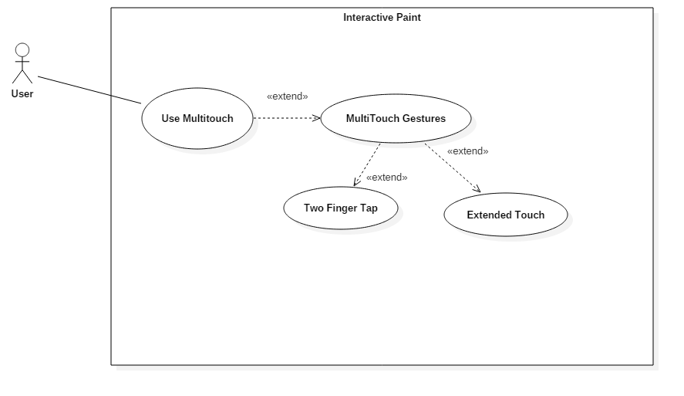

**Sequence Diagram**

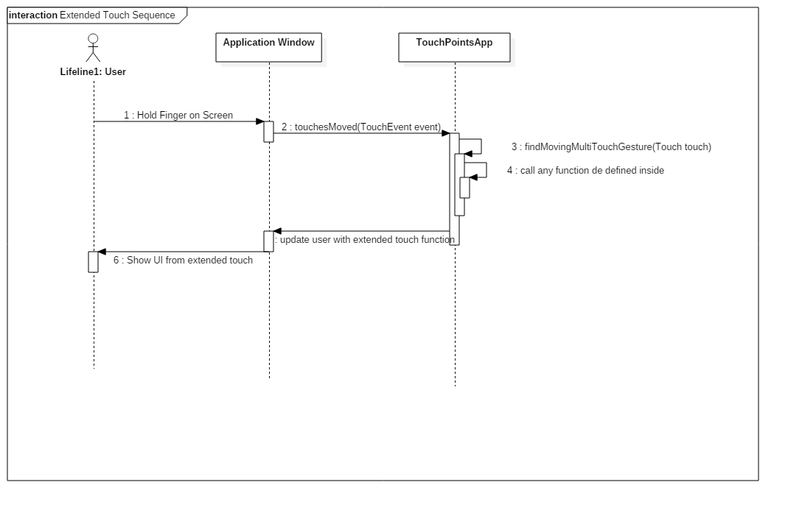

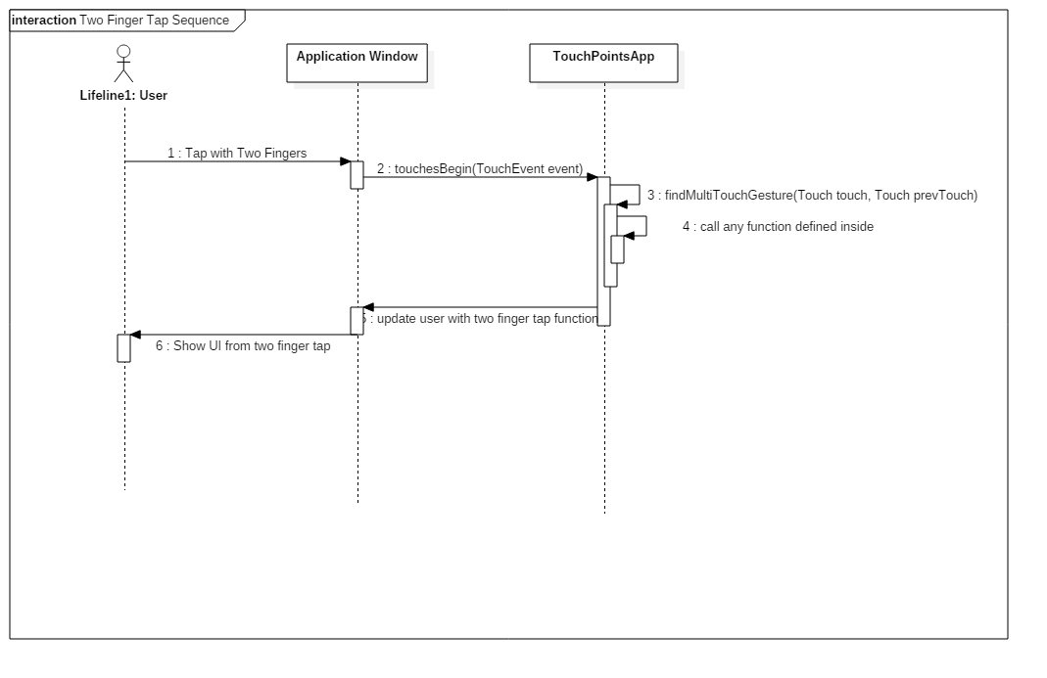

**Class Diagram**

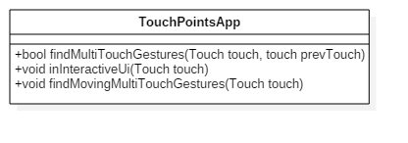

**Unit Test**

Sunny Day:

Test Case: Extended Touch Gesture Working

Test Purpose:

Make sure the Extended Touch Gesture is working

Test Setup

1. Ensure multitouch is working
2. Press finger to screen and hold it for about 1 second.
3. Hold finger for 3 additional seconds.

Test Output:

After holding for one second shape changed to open circle

While holding the finger down for 3 additional seconds the shapes continued to cycle through.

Expected Output:

After .75 seconds of the finger touching the screen, the shape should change.

Every .75 seconds the finger is held down afterwards continues to change the shape.

Test Case: Double Tap Gesture Working

Test Purpose:

Ensure that the double tap gesture is working.

Test Setup

1. Ensure the multitouch is working
2. Push your pointer and middle finger together
3. Make sure the middle finger is not too far above the pointer finger (Should be up to about a quarter inch above the pointer finger).
4. Tap the screen briefly with bother fingers
5. Lift fingers immedietly

Test Output:

After step 4 ‘Red’ box popped up indicating we changed color to red.

Expected Output:

Color should change.

Rainy Day Tests:

Test Case: ‘Peace Sign’ drawing.

Test Purpose:

Make sure the application doesn’t accidently detect a double tap gesture.

Test Setup

1. Ensure multitouch is working.
2. Do a ‘Peace Sign’ with your hand (split the pointer and middle finger up)
3. Attempt to draw two lines on the canvas.

Test Output:

Drew two lines on the canvas.

Expected Output:

When the fingers are separated you should draw two lines (No color change should occur)

**Integration Test**

Currently works with the multitouch acer device. After performing these gestures functionality for drawing as well as interacting with UI elements remains intact.

Works with the older gesture as well (Double tap). They can still be performed separately.

Any color or shape changes that occur with these gestures are also working with the leap motion device in addition to the multitouch device. The changes are also reflected in the mode box properly.

**User Guide**

Extended Touch:

For the extended touch gesture simply press onto the canvas (non- buttons, drawing area). Press your finger to the screen until the ‘circle’ of your touch turns to a square (~.75 seconds). You can see the ‘Square’ that pops up when your touch is extended in the image below, it is the grey square located near the top right of the image.

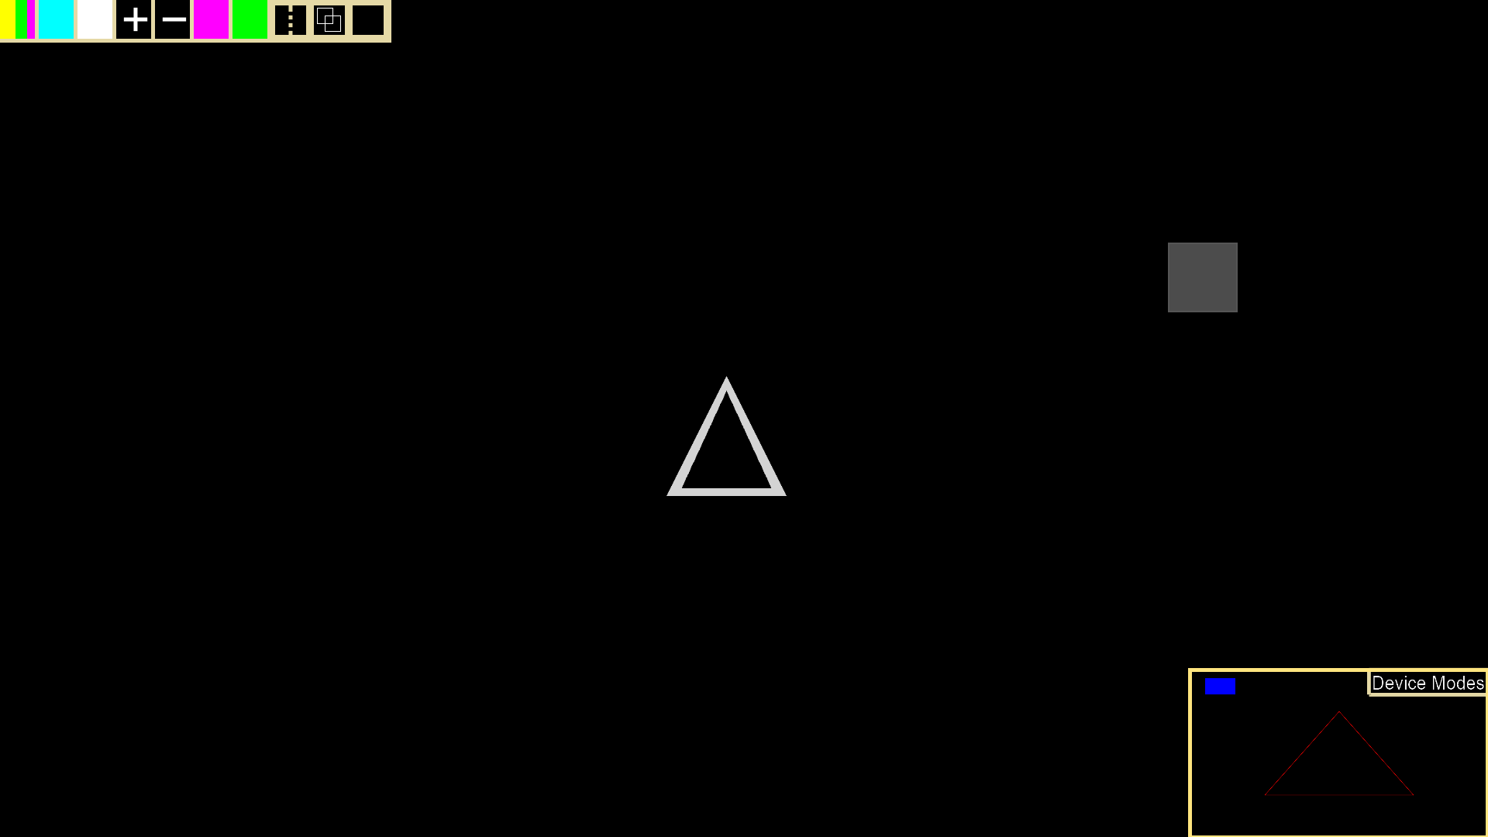

For the two finger tap, you must put your pointer and index fingers together, then tap the screen. Make sure the screen is registering two separate taps, and that your fingers are not to ‘high’ above each other (Your fingers shouldn’t be much more than a quarter inch height difference). Below you can see an example of the two finger tap. The center of the two grey circles represent where the fingers touched the screen.

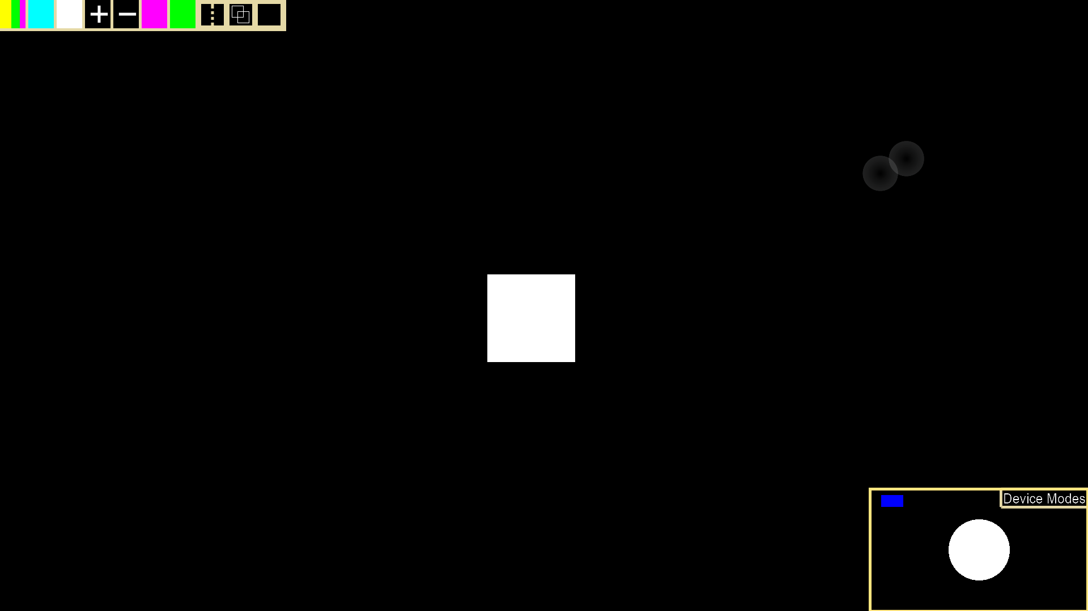

**Glossary**

Multitouch Gestures

Extended Touch – Multitouch gesture where the user touches the screen and does not move for .75 seconds.

Two Finger Tap – Multitouch gesture where the user taps with two fingers next to eachother (20~ pixels to 75 ~ pixels apart, and up to 120 pixels up and down).